**Project Design Phase-II**

**Data Flow Diagram & User Stories**

|  |  |
| --- | --- |
| Date | 26-06-2025 |
| Team ID | LTVIP2025TMID59691 |
| Project Name | Flightfinder |
| Maximum Marks | 4 Marks |

**Data Flow Diagrams:**

A Data Flow Diagram (DFD) illustrates how data moves within the Flight Finder platform. It maps out the interaction between users (travelers and admin), the booking system, and various data processes such as flight search, booking confirmation, payment processing, and notifications. The DFD helps identify inputs, outputs, data storage, and communication between components.

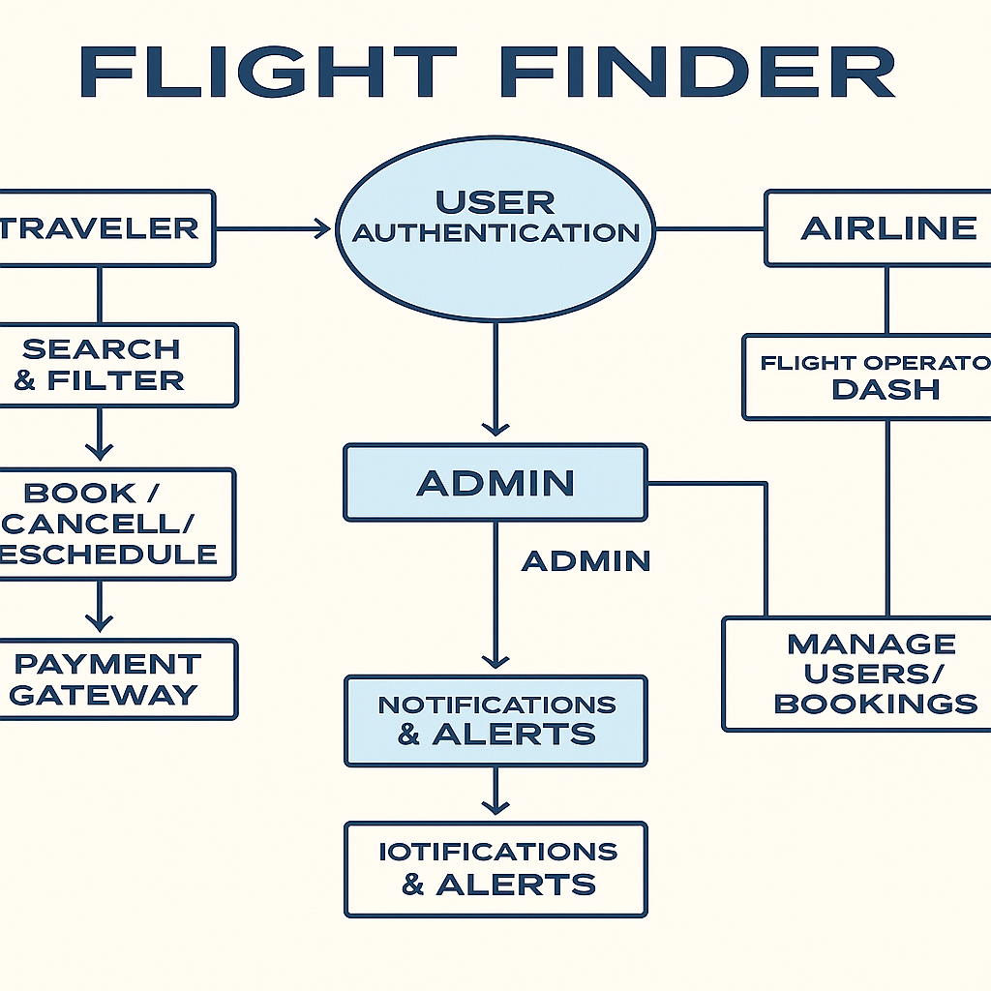

**User Stories**

**User Story Table – Flightfinder**

|  |  |  |  |  |  |
| --- | --- | --- | --- | --- | --- |
| **User Type** | **Functional Requirement (Epic)** | **User Story / Task** | **Acceptance Criteria** | **Priority** | **Release** |
| Traveler | Flight Search | As a traveler, I can search for flights by source, destination, and date. | Relevant flights appear based on search filters. | High | Sprint-1 |
| Traveler | Booking Management | As a traveler, I can book, reschedule, or cancel flight bookings. | Booking status updates and reflects in dashboard. | Medium | Sprint-2 |
| Traveler | Profile Management | As a traveler, I can update my personal information and travel preferences. | Changes are saved and reflected in the profile. | Medium | Sprint-2 |
| Traveler | Notifications & Alerts | As a traveler, I get email/SMS alerts for fare drops and booking confirmations. | Notifications are received timely based on conditions set. | Medium | Sprint-3 |
| Admin | Flight Management | As an admin, I can add, update, or delete flight listings. | Flights are updated instantly on the platform. | High | Sprint-1 |
| Admin | User Moderation | As an admin, I can review reports and take actions on flagged users or listings. | Actions taken are logged and visible in the admin dashboard. | High | Sprint-2 |
| Traveler | Payment System | As a traveler, I can make secure payments and view transaction history. | Payment is recorded and visible under transaction section. | High | Sprint-2 |
| **Admin** | User Moderation | As an admin, I can review reported users and take action. | Reports and actions logged. | High | Sprint-1 |